1. **Display the name of the employee who gets maximum salary**

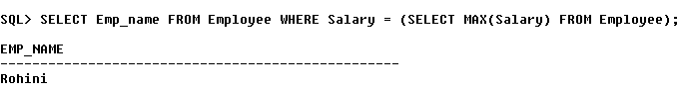

1. **Count the total number of companies.**

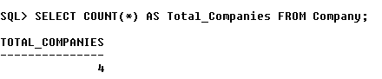

1. **Display ID all employees in sorted order according to salary.**

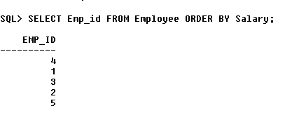

1. **Display Name of the employee having a salary lower than the average salary of all employees.**

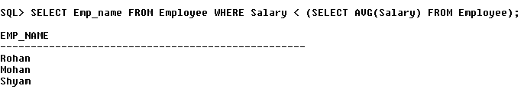

**5. Find company details where the company name starts with ‘H’.**

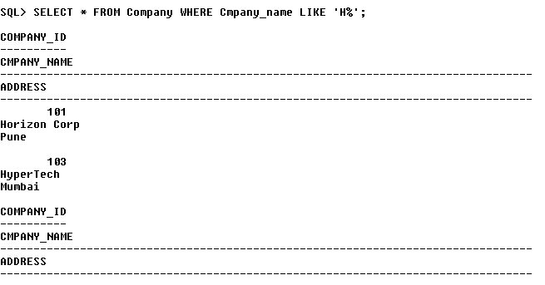

**6. Find the Address and Company_Id having same address.**

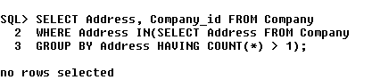

**7. Write a Oracle SQL query to get the details of all employees and also display the specific information of all employees.**

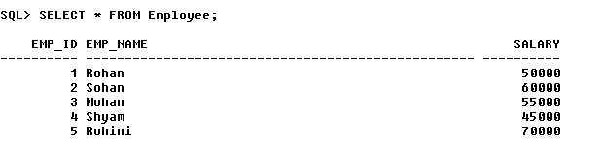

**8. Write a Oracle SQL command to display the employee name and annual salary for all employees.**

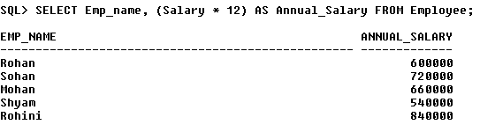

**9. Write a Oracle SQL query to get the total number of employees working in the company.**

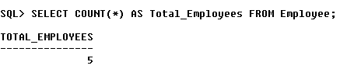

**10. Write a Oracle SQL query to get the total salary being paid to all employees.**

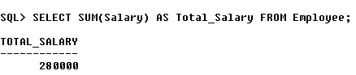

**11. Write a Oracle SQL query to get the maximum and minimum salary from the employees table.**

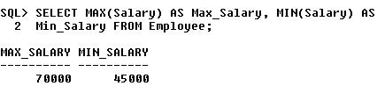

**12. Write a Oracle SQL query to display the name of the employees in order to earning from lowest salary to highest.**

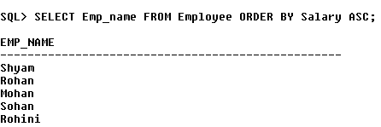

**13. Write a Oracle SQL query to display the name of the employees in order to earning from highest salary to lowest.**

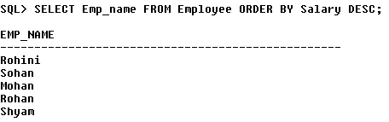

**14. Write a Oracle SQL query to display the name of the employees in order to alphabetically ascending order.**

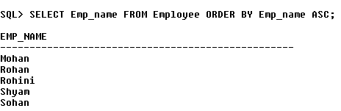

**15. Write a Oracle SQL query to display employee id, name, department no, salary of the employees. The output first based on the employee name in ascending order, for unique name department will come in ascending order, and for same name and department the highest salary will come first.**

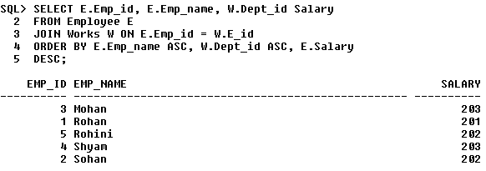

**16. Write a Oracle SQL query to display the name and their annual salary. The result should contain those employees first who earning the highest salary.**

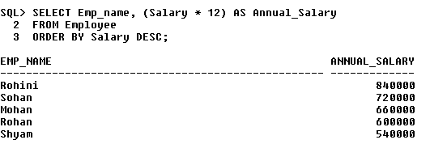

**17. Write a Oracle SQL query to display department id and total number of employees working in each department.**

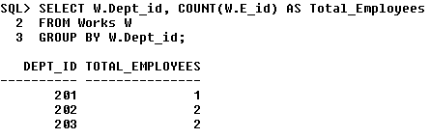

**18. Write a Oracle SQL query to display the designation (job id) and total number of employees working in each designation.**

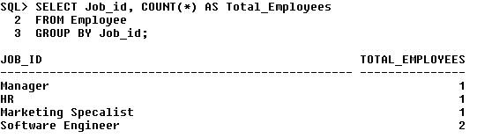

**19. Write a Oracle SQL query to display the department number and total salary for each department.**

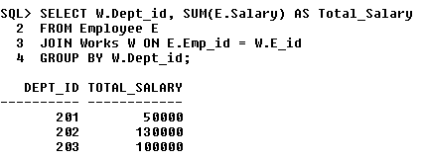

**20. Write a Oracle SQL query to display the department number and maximum salary for each department.**

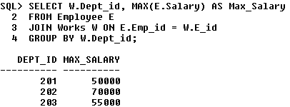

**21. Write a Oracle SQL query to display the designations (job id) and total salary allotted for each designation from the company.**

